http://www.visitwales.com/explore/accessible-wales/wheelchair-access-beaches

Abersoch, Llyn Peninsula
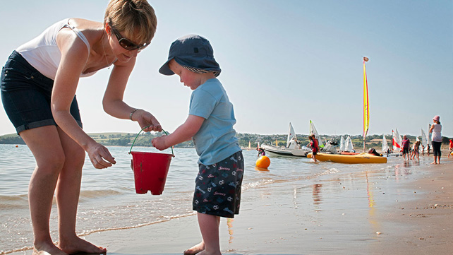
Abersoch, Llŷn Peninsula, Snowdonia
This part of North Wales is sailing central. If your kids are keen to learn the ropes or improve their skills in dinghy sailing, kayaking or windsurfing, Abersoch Sailing School will be happy to help. Abersoch’s sandy beach is fairly sheltered, with no strong currents, so perfect for lazy summer days. There’s disabled access via a very gentle slope near the golf club.

Benllech, Anglesey
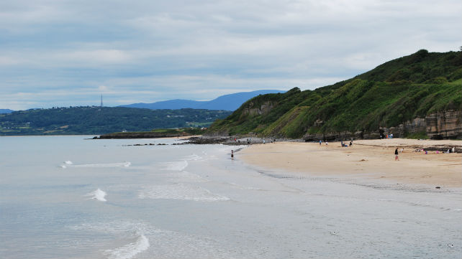
Benllech Beach, Anglesey by davep90
Benllech beach has easy access for prams, pushchairs and wheelchairs, the Blue Flag beach on Anglesey’s east coast is ideal for a family day out. With wide sands, rock pools and safe, clear water to enjoy, it’s an appealing place to relax in the sun or go sea kayaking or windsurfing. There are cafés and shops close to the bay, and more in the small holiday town of Benllech.

Broad Haven Pembrokeshire
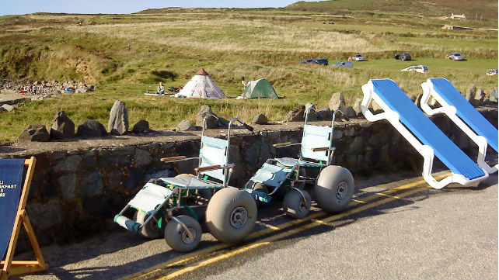
Beach wheelchairs for hire in Pembrokeshire by JenThornton
The wonderful, safe beach at Broad Haven near Haverfordwest is one of several in Pembrokeshire where all-terrain wheelchairs are available to rent. They’re comfortable, with extra wide wheels that can cope with sand and shallow water without sinking. To reserve one in advance, contact Haven Sports Surf Shop on Marine Road (01437 781354, info@havensports.co.uk).

Langland Bay Gower Peninsula
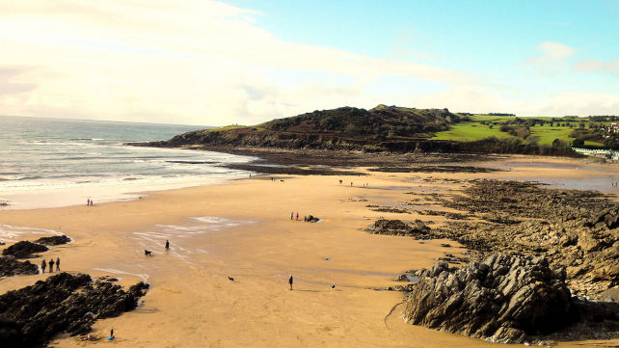
Langland Bay, Swansea
by Snap Happy Wales
Langland, which is accessible to all, is one of the most popular beaches on the Gower Peninsula. The locals, who have been swimming, beachcombing and canoeing here for generations, were among the first in Britain to catch on to the American surfing craze in the 1950s and 1960s and the bay is still one of Wales’ top surfing spots. An all-terrain wheelchair can be reserved on 01792 635411.

New Quay Harbour Ceredigion
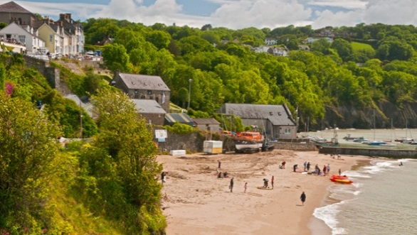
Harbour Beach in New Quay, Ceredigion
The characterful Victorian terraces which inspired Dylan Thomas so profoundly in the 1940s cluster above a pretty little bay, where sailing dinghies bob in the water at high tide. Many of New Quay’s streets are steep, but there’s sloping access all the way down to the sand. Bottlenose dolphins are often seen just beyond the bay. Discover more about New Quay Harbour beach.

Prestatyn Central Denbighshire
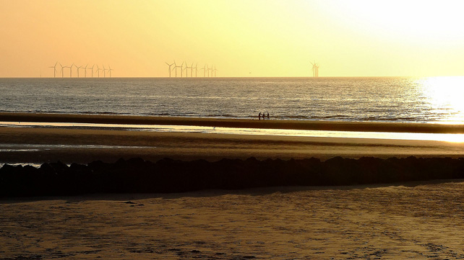
Prestatyn beach by S Wainwright
Prestatyn has four miles of sandy beaches, the most accessible of which is Central Beach. This Blue Flag beach is only half a mile from the town centre, at the northern limit of the Offa’s Dyke National Trail. The facilities are great, with easy parking, outdoor showers, cafés, deckchairs and a new play area. There are lifeguards on duty here in the summer months.

Rhos-on-Sea, Conwy
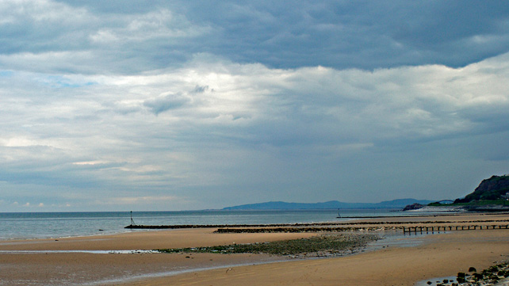
Rhos on Sea, Llandudno & Colwyn Bay by raindrop2011
The beach at Rhos-on-Sea is sheltered by a breakwater which ensures the sand never completely disappears, even at high tide. There’s plenty of free parking nearby. Rhos-on-Sea promenade is home to the Harlequin Puppet Theatre, Britain’s oldest permanent theatre for marionettes, with regular shows in the holidays.

Saundersfoot Pembrokeshire
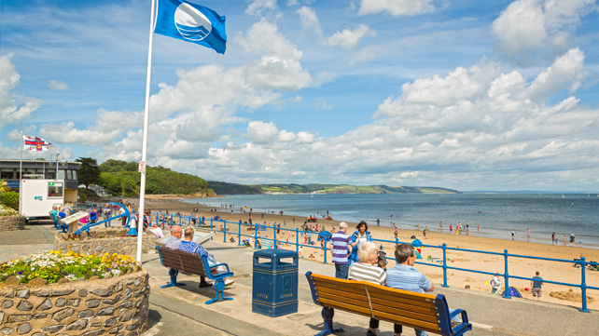
Saundersfoot Beach, Pembrokeshire
With golden sand and a substantial slipway, Saundersfoot near Tenby is an idyllic spot for sunbathing, swimming and sailing. Saundersfoot has four all-terrain wheelchairs, two full-sized and two child-sized, donated by local charities. These can be hired for a small fee. To book in advance, contact the Tourist Information Centre (01834 813672,saundersfoot.tic@pembrokeshire.gov.uk).

Whitesands Pembrokeshire
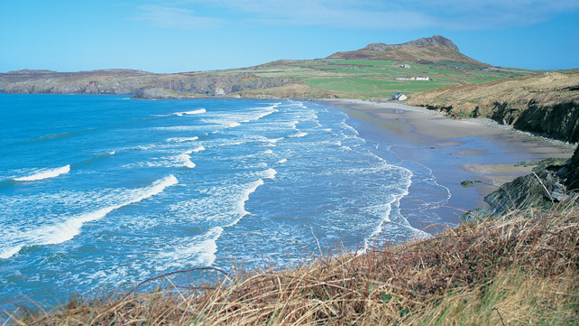
Whitesands Bay, Pembrokeshire
Reached by a winding country lane from the perfect little city of St Davids, this gorgeous Pembrokeshire bay is a firm favourite of swimmers, surfers and holidaymakers camping at one of the nearby campsites. In summer, it’s best to arrive early, especially if you’re driving – it gets busy. The local beach deckchair service (01437 720692) has two all-terrain wheelchairs for hire. Find out more about Whitesands beach.

Whitmore Bay Barry Island
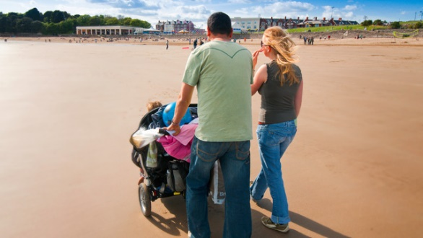
Whitmore Bay, Barry
The Barry Island Tourist Information Centre (01446 747171) has three all-terrain beach wheelchairs which they lend out for free – you just need to show some ID. The beach is a real family favourite, but if it’s not sunbathing weather, you could head into Cardiff Bay to go sailing at Cardiff Sailing Centre, which has RYA Sailability training facilities for disabled sailors.

